**Azure Load Balancer**



Azure Load Balancer is a Layer 4 (TCP/UDP) load balancing service that distributes incoming network traffic across multiple virtual machines for high availability and scalability. It supports both inbound and outbound scenarios with low latency and high throughput.

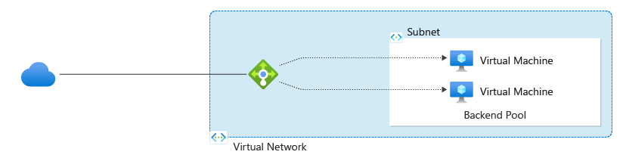

**Features :**

1. **Layer 4 Load Balancing** – Distributes TCP and UDP traffic across multiple backend VMs or instances.
2. **High Availability** – Ensures application resilience by rerouting traffic from unhealthy to healthy instances.
3. **Inbound and Outbound Traffic Support** – Balances both incoming (public) and outgoing (internet-bound) traffic.
4. **Health Probes** – Automatically monitors the health of backend resources and directs traffic accordingly.
5. **Multiple Frontends** – Supports multiple IP configurations and ports for flexible traffic distribution.